ECA0303 SIGNALS AND SYSTEM
NAME : BHARATH A
REG NO : 192512384
2. SIGNAL PROPERTIES AND TRANSFORMATIONS
Experiment 2.1
Periodic and Aperiodic Signals
Program:
% Test Case: Generation of Periodic and Aperiodic Signals

clc;
clear;
close all;

%% Parameters for the Periodic Signal (Sinusoidal)
f_periodic = 1; % Frequency in Hz
A_periodic = 1; % Amplitude
t_periodic = 0:0.01:2; % Time vector (0 to 2 seconds)

% Generate the periodic signal
x_periodic = A_periodic * sin(2 * pi * f_periodic * t_periodic);

% Plot the periodic signal
subplot(2,1,1);
plot(t_periodic, x_periodic, 'b', 'LineWidth', 1.5);
grid on;
xlabel('Time (s)');
ylabel('Amplitude');
title('Periodic Signal: Sinusoidal Wave (1 Hz)');

%% Parameters for the Aperiodic Signal (Exponentially Decaying)
a_aperiodic = 0.5; % Decay constant
A_aperiodic = 2; % Amplitude
t_aperiodic = 0:0.01:2; % Time vector (0 to 2 seconds)

% Generate the aperiodic signal
x_aperiodic = A_aperiodic * exp(-a_aperiodic * t_aperiodic);

% Plot the aperiodic signal
subplot(2,1,2);
plot(t_aperiodic, x_aperiodic, 'r', 'LineWidth', 1.5);
grid on;
xlabel('Time (s)');
ylabel('Amplitude');
title('Aperiodic Signal: Exponentially Decaying Signal');
Output waveform :
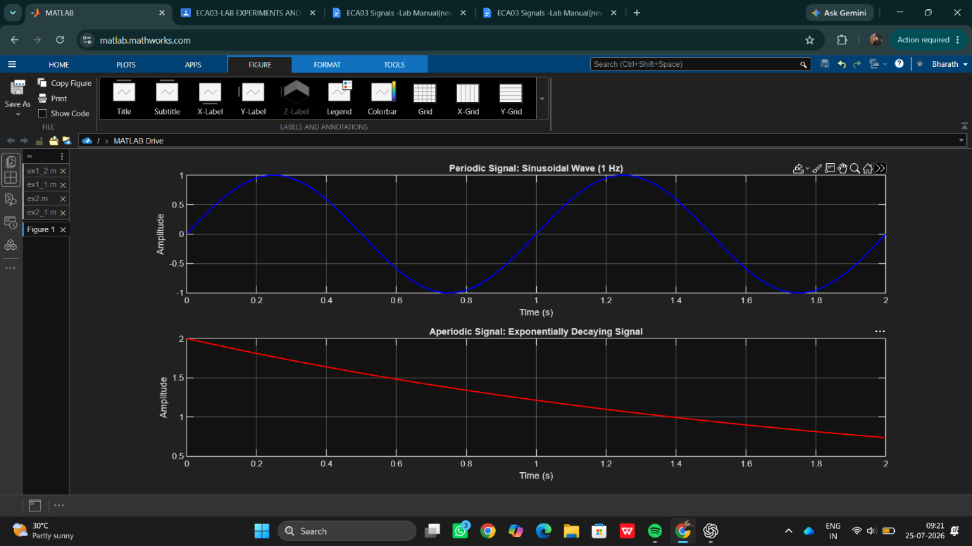
Result:
● Periodic Signal: The sinusoidal signal repeats itself at regular intervals, making it periodic.
● Aperiodic Signal: The exponentially decaying signal does not repeat, showcasing that it is aperiodic.
This test case illustrates the key differences between periodic and aperiodic signals by generating and visually analysing both types using Matlab.

